**Task on Autoscaling Groups.**

1. **Create one vpc in N.virginia region.**

**Created one vpc in Tokyo region , because on N ,VIRGINAE another user**

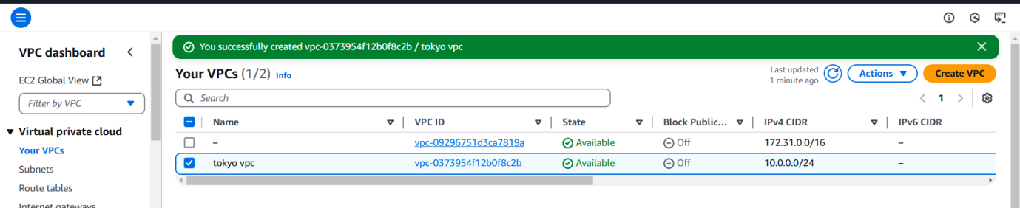

**2) Create two subnets.**

**One Public subnet and one private subnet.**

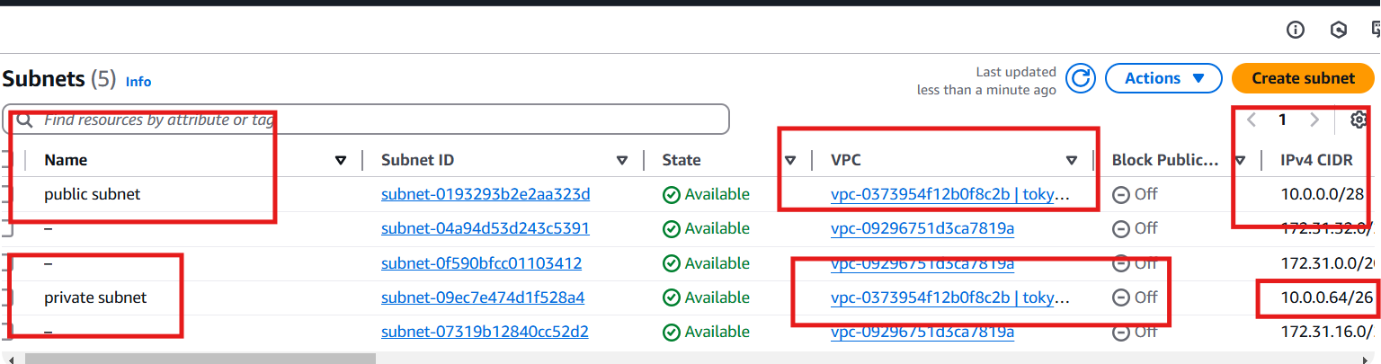

**3) Provide the IGW and attach to the vpc.**

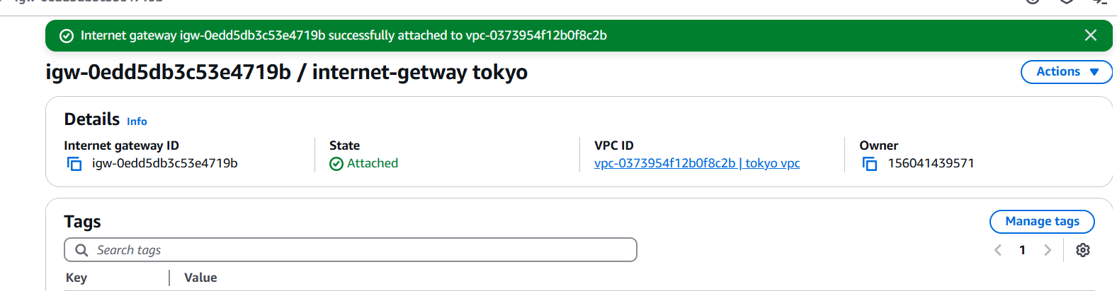

**4) Create One public RT and one private RT.**

Step

**Rename one public route to newly created vpc TOKYO, and created one private route table**

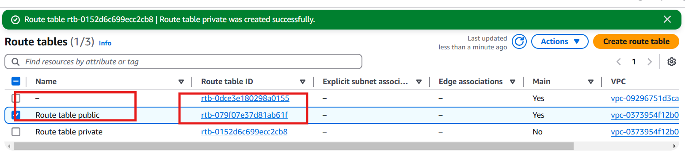

**Step 2 add internet gate way to public route table and edit routes**

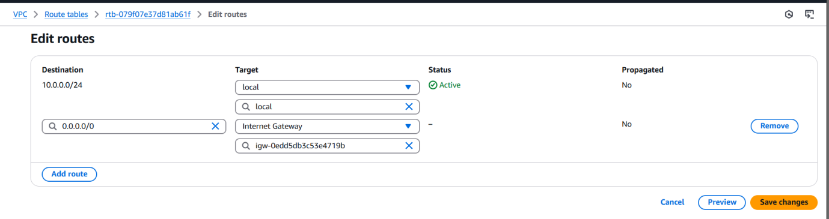

**Step 3 edit subnet association for public route table**

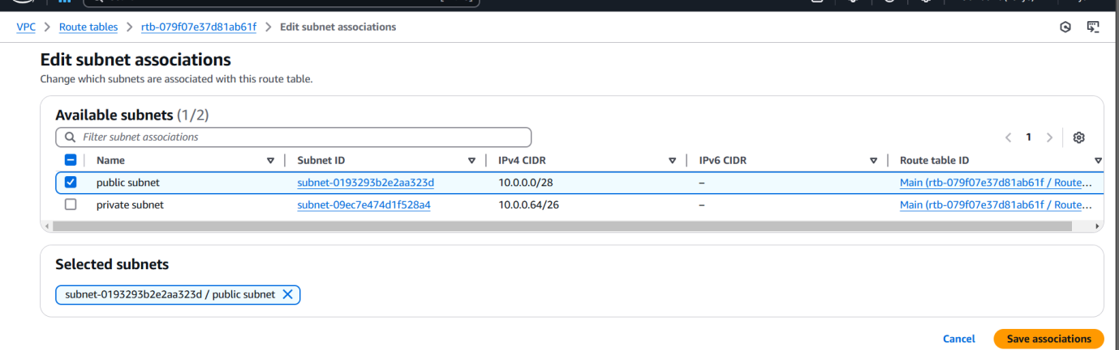

**Step 4 edit subnet association for private route table**

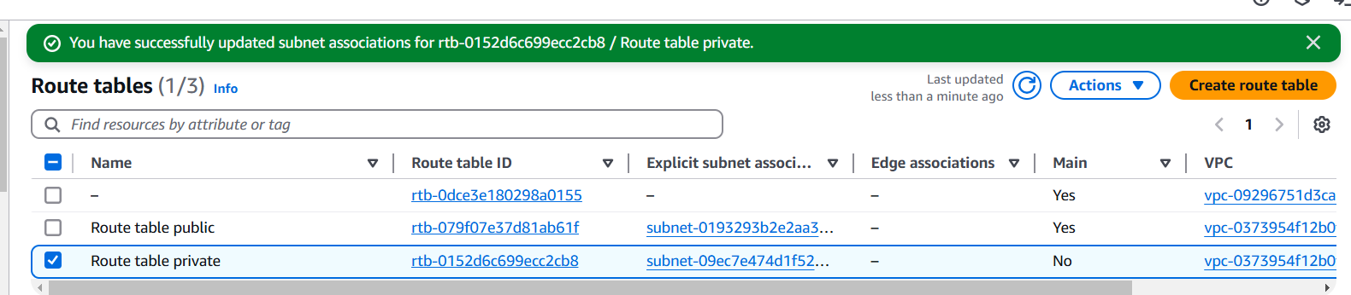

**5) Deploy NAT gateway on public subnet and attach the NAT gatewat to private subnet.**

**Step 1: Go create NATgateway and allocate one elastic ip to and select private subnet** 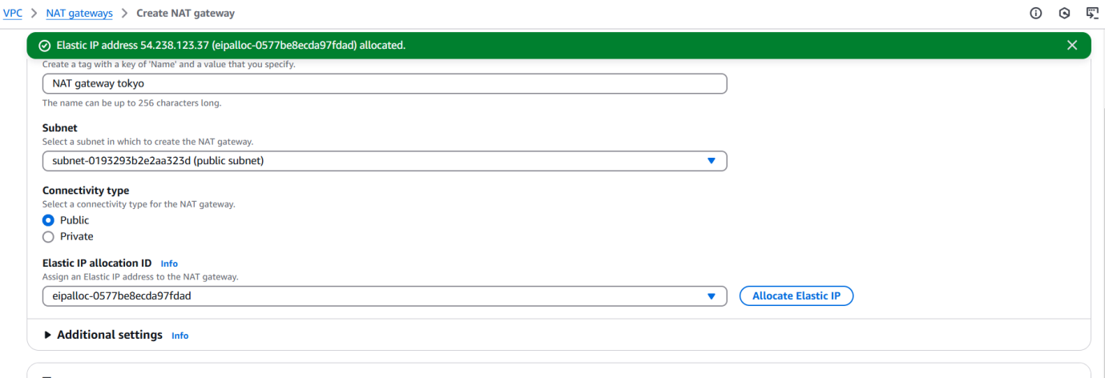



**NAT GATEWAY created**

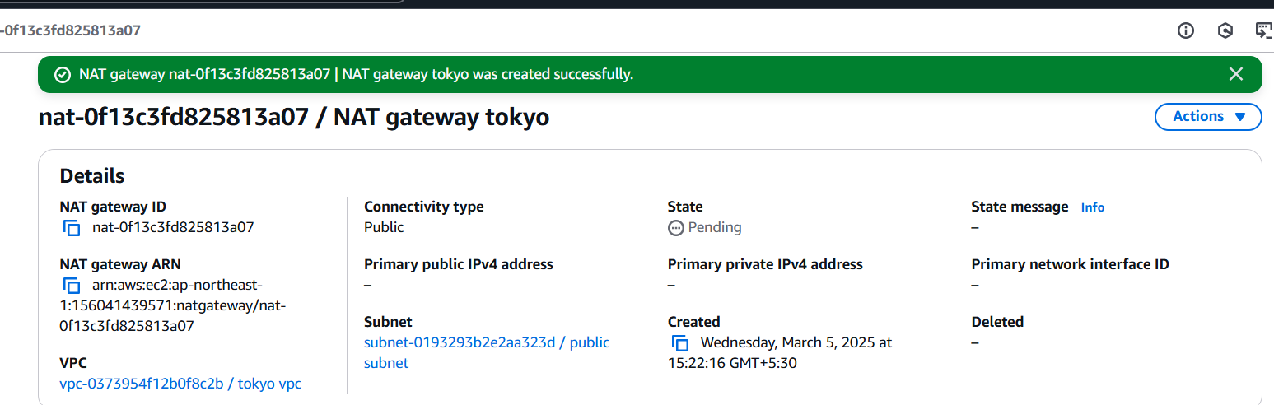

**6) Create Two instances,one in public subnet and one in private subnet.**

**Step 1 created 1 publice ec2 and attached private subnet with vpc Tokyo**

**Step 2 created 1 private ec2 and attached private subnet with vpc tokyo**

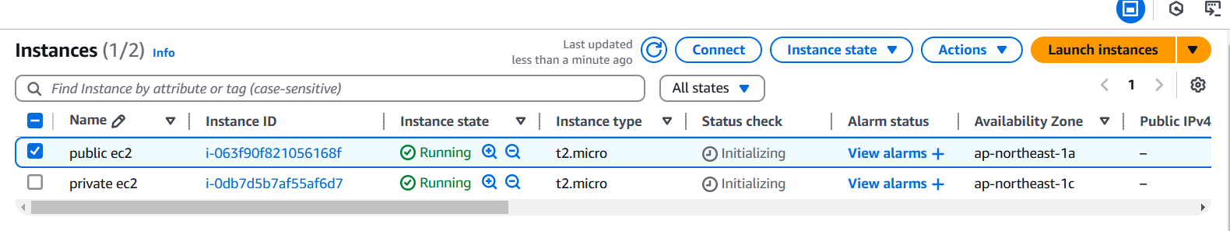

**Step3 go to vpc and route table and select private subnet then edit routes**

**Destination 0.0.0.0 and Target NAT gateway savechanges**

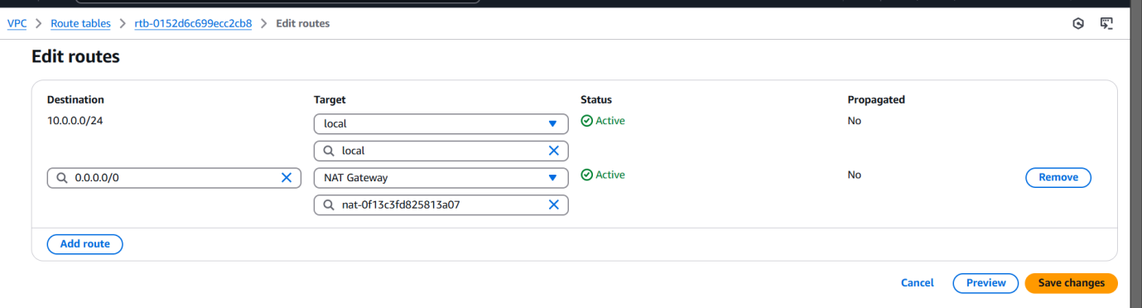

**Step4 I can able to ping from pivate ec2 to google.com**

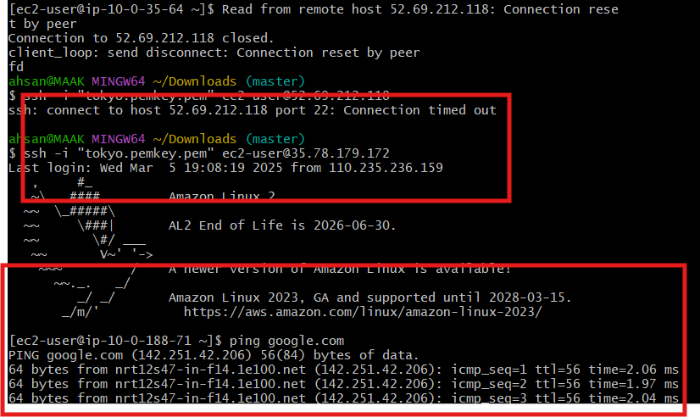

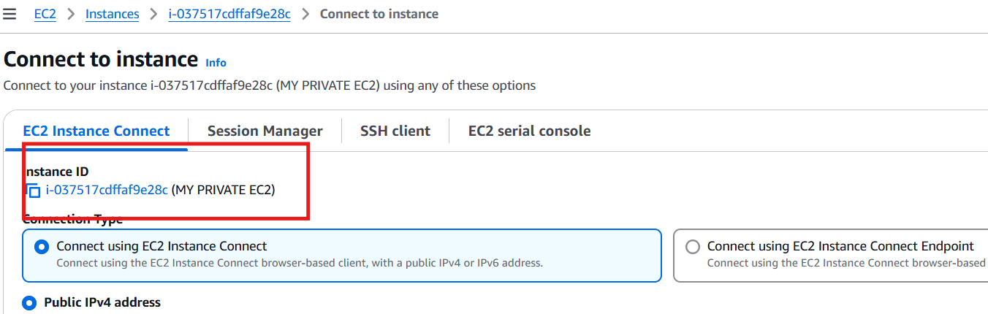

**7) Deploy Apache server on both the ec2 instances with sample index.html file.**

**8) Create one application load balancer and attach the load balancer to both the ec2 instances.**

**9) Store Application load balancer logs to s3.**

**10) Store the vpc flow logs to cloudwtach group.**

**11) Create Monitoring Dashboards to monitor cpu utilization and to monitor apache service.**

**12) CPU utilizationis more than 70% then it should triggere Autoscaling and launch new instance.**